2.0[1]

Hello Neighbor: Grounded

Version 3.2

|  |  |
| --- | --- |
| Designer: | William Bracho Blok |
| Document Date: | 11/26/2018 |
| Intended Level Delivery Date: | 11/26/2018 |

**Document Revisions Table**

|  |  |  |  |
| --- | --- | --- | --- |
| **Version** | **Description** | **Requestor** | **Date** |
| 1.0 | Initial Document | Professor Ouellette | 9/26/2018 |
| 2.0 | Level Design Document Iteration 1 | Professor Ouellette | 10/1/2018 |
| 3.0 | Refine Level Layout | Professor Ouellette | 10/22/2018 |
| 3.1 | Revised level objectives | Professor Ouellette | 10/31/2018 |
| 3.2 | Water/ice puzzle iteration, added alternate way to get into pool shed, added gameplay on house roof | Professor Ouellette | 11/26/2018 |

# Table of Contents

Table of Contents 2

Quick Summary 4

Design Goals 4

Level Map First Floor 5

Level Map Roof and Outside 6

Map Common Legend 7

Level Main Objectives 8

Exit out of the Starting Room 8

Summary 8

Puzzle Flow 8

Find and Activate Gasoline Generators 1 and 3 15

Summary 15

Puzzle Flow 16

Gain Access into the Office Room to Pick the Wrench 21

Summary 21

Entering Through the Roof Opening 23

Entering Using the Green Key 26

Puzzle Flow 28

Find and Activate Generator 2 29

Summary 29

Enter the Pool Shed to Pop the Handle out of the Pressure Meter 29

Summary 29

Logic Behind Puzzle 31

Puzzle Flow 31

Feed Water to the Steam-Powered Garage Gate Motor 32

Summary 32

Puzzle Flow 32

Open the Exit gate and Escape 33

Additional Level Design Highlights 35

The House Backyard 35

Gasoline generator Numbering 35

Custom Blueprint Functionality 35

Unlockable Paths 35

Additional Features that required custom blueprint functionality: 36

References 37

Level Design Document

# Quick Summary

Grounded is a Hello Neighbor mod where the player is a rebel teenager who has be grounded and locked away by his recluse and socially-awkward father Sosed after stealing his car for a night and wrecking it in a car accident. The player must figure a way to get out of the house to break free from Sosed’s punishment and regain freedom. The player also needs to be careful and avoid being spotted by his very vigilant father as he will chase the player down and send them back to their room.

# Design Goals

This level was designed with five goals in mind:

1. The puzzles start out easy and get progressively difficult as players progresses through the level.
2. Because dealing with the neighbor (in this case, the father of the teenager) is a big part of the Hello Neighbor experience, the level must have plenty of flow options and features that they can use to sneak around and outsmart the father.
3. The level should have some cool, entertaining, and memorable parts that feel rewarding to the player.
4. The level should have a villa-style architecture (thematic/aesthetic choice).
5. The mod must give approximately 10 minutes of gameplay as requested by stakeholder.

# Level Map First Floor

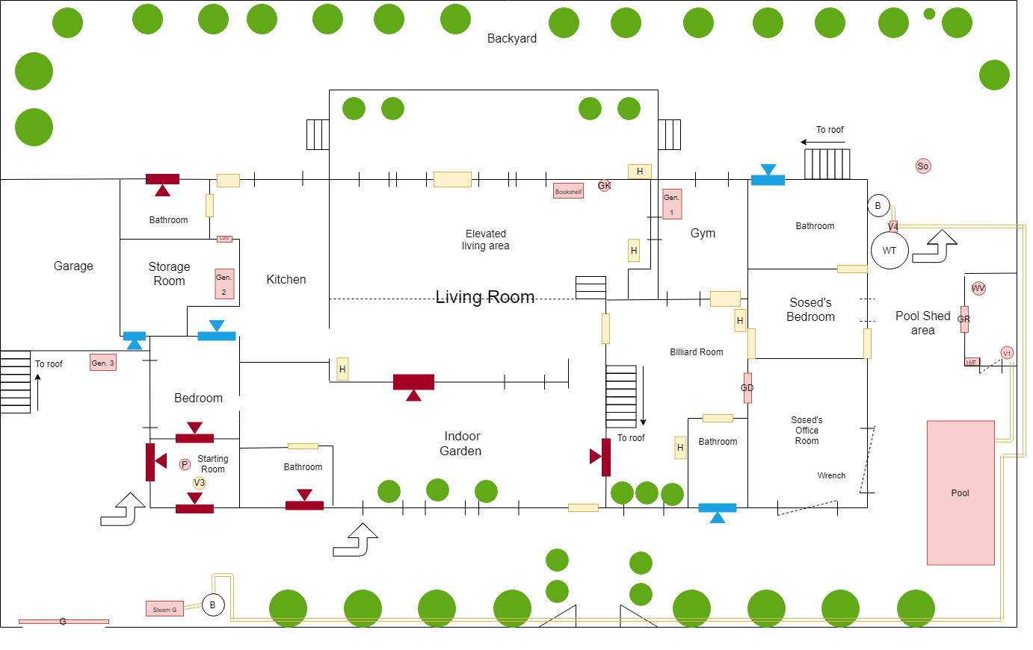

Figure 1: top-down diagram of the first (main floor) of the level. Most of the clutter has been removed from the map for better readability

# Level Map Roof and Outside

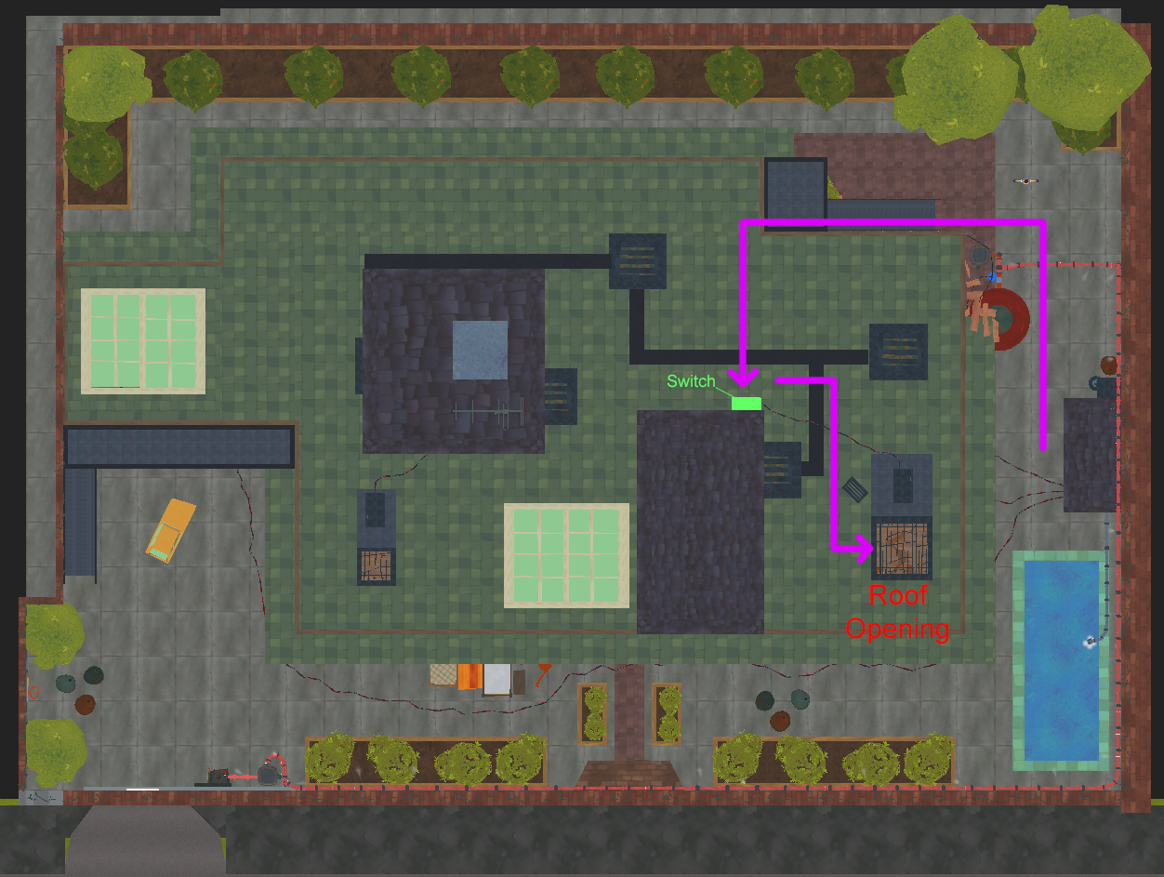

Figure 2: top view of the level in the UE4 editor (unlit) showing the roof and the outside of the house

# Map Common Legend

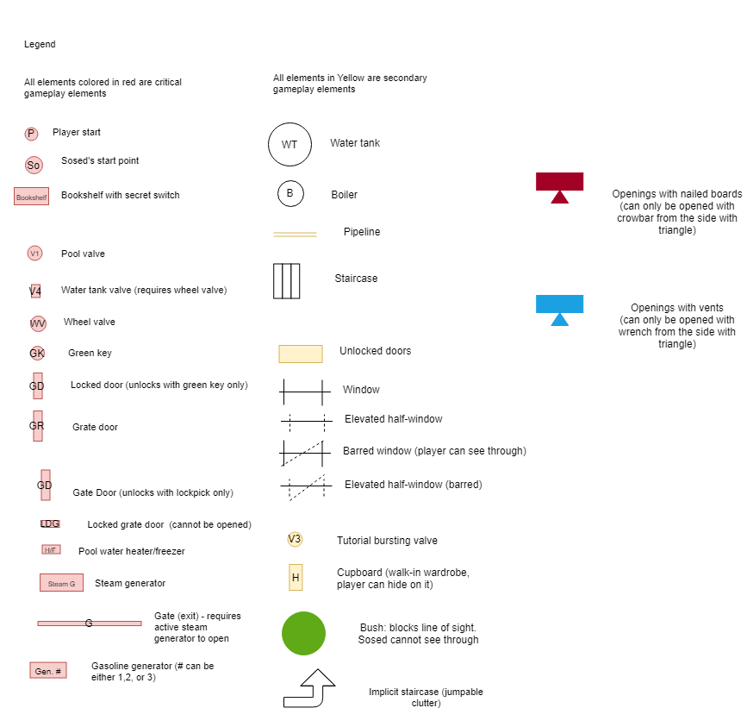

Figure 3: this is a legend that is common for all diagrams used in this document

# Level Main Objectives

The player starts out locked in his room, and to escape the house, he needs to:

1. Exit out of the starting room
2. Find and activate gasoline generators 1 and 3
3. Gain access into the office room to pick the wrench
4. Find and activate generator 2
5. Enter the Pool Shed to Pop the Handle out of the Pressure Meter
6. Feed water to the steam-powered garage gate motor
7. Open Exit gate and Escape

The following sections in this document will explain in detail how the player is intended to complete the level’s main objectives. Each step may contain a summary sub-section and a puzzle flow sub-section. The summary section summarizes how the player completes the corresponding step to solve the puzzle whereas the puzzle flow goes more in detail about how the puzzle is meant to flow, what does the level do to convey the player what to do next and go over some of the design highlights of the level.

## Exit out of the Starting Room

### Summary

The player starts locked in a room with boarded windows (see **figure 4**) and the room’s door locked from the other side with clutter. There is a roof opening that is locked with a grate hatch that has a crowbar hanging on one of the bars of said grate (see **figure 5)**. There is also some exposed water ground pipeline; one of these pipes is clogged with a cork, has a valve, and is pointing to the crowbar hanging on the ceiling. To break free from this room, the player must:

1. Open the pipe valve. Because the pipe is clogged, pressure will build up on the pipe and pop the cork out. The cork hits the crowbar hanging on the ceiling and knocks it out so that it falls to the floor. The player must pick up the crowbar to proceed.
   1. This part of the level is meant to be a tutorial/hint to the idea that pushing water through a pipe can generate pressure and pop things out.
2. Use the crowbar to remove the nailed boards from the room that are facing the player and exit.

### Puzzle Flow

The level starts with the player locked inside a room with the windows boarded from the inside and the doorway blocked with a cluster of furniture. The first thing that players they see is the first thing they need to interact with to proceed to the level: a pipe sticking out from the ground with a handle and a cork stuck on its end that is being highlighted by light casted from a ceiling opening. As the player approaches it to inspect it, they might also look up to see where the light is coming from, and if they look up, they see that there is a ceiling opening that is locked with a grate hatch and has a crowbar hanging on it. From real life experience, player might know that they could use a crowbar to remove the nails from the boards blocking the windows, so players might attempt to get the crowbar; however, it is placed high enough so that players can’t reach it by jumping, thus, players would proceed to investigate the pipe that initially got their attention.

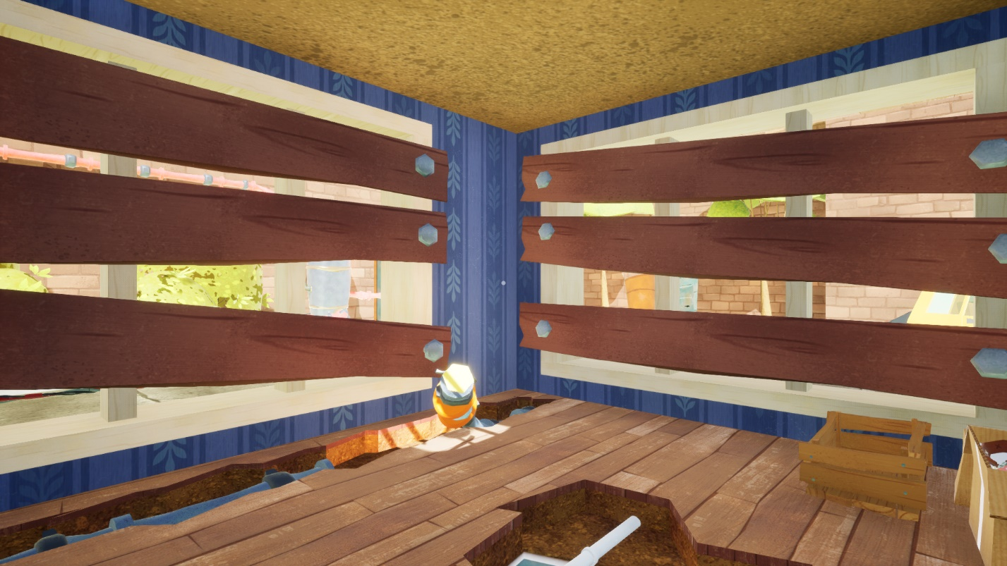

Figure 4: what the player sees as soon as they start the level

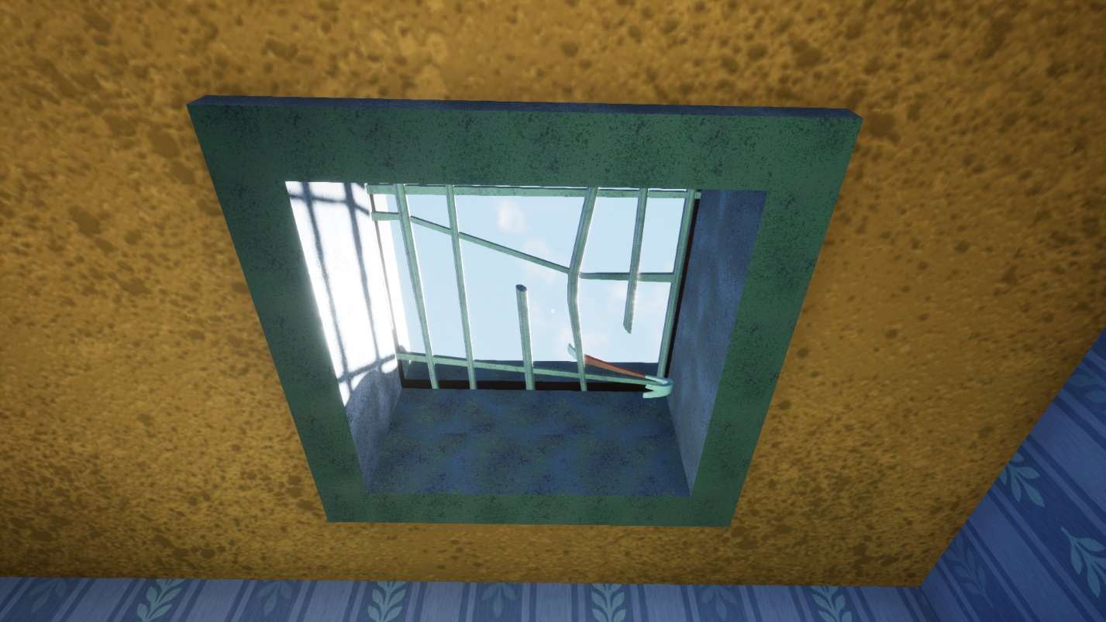

Figure 5: what the player sees at the starting room when looking up at the source casting light

As they get closer to the pipe, players will notice that it has a handle attached to it, and because there aren’t many things to experiment in the starting room, they’ll eventually actuate it to pop the cork out and knock the wrench hanging from the ceiling opening. This vignette with the pipe popping out and knocking the crowbar down was designed so that it hints the player that they need to use the crowbar to get out; the pipe is pointing towards the crowbar on the ceiling, and once the cork is popped out of the pipe and the cork knocks the crowbar to the ground, players can see and hear the loud sound of the crowbar impacting the wooden floor from the room, which also serves as a way for the level to present the crowbar to the player and hints them that tool-like objects are useful in this game, such as the crowbar. Additionally, the crowbar and the nails holding the wood pieces blocking the windows have a similar color, which also hints the player about the connection between the crowbar and the nails. Another reason why this vignette was set up was to also entertain the player and give them a cool little moment for players to get amused and possibly laugh, which contributes to design goal #3.

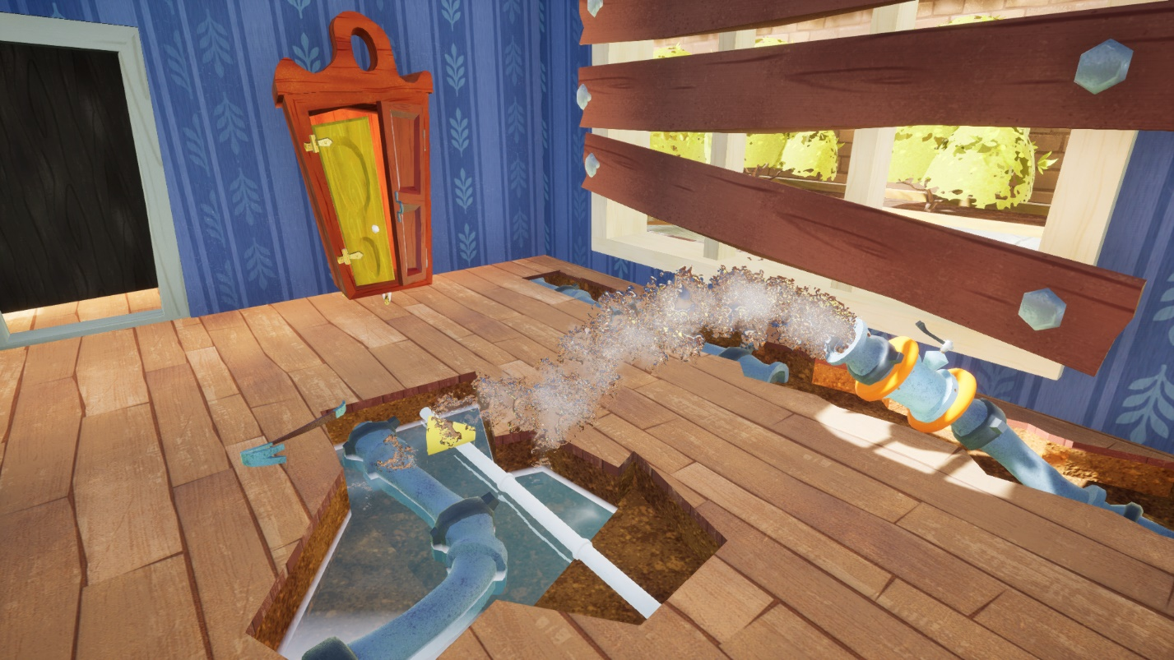

Figure 6: image of the pipe after opening its valve to pop the cork out and knock the wrench down

Once the player removes the boards blocking the windows from the starting room with the crowbar, they will see either their final objective, which is the exit gate as shown in **figure 7** with a motor-like component, or if they leave through the other window, they’ll see part of their next objective, the gasoline generator with a number attached to it as shown on **figure 8**.

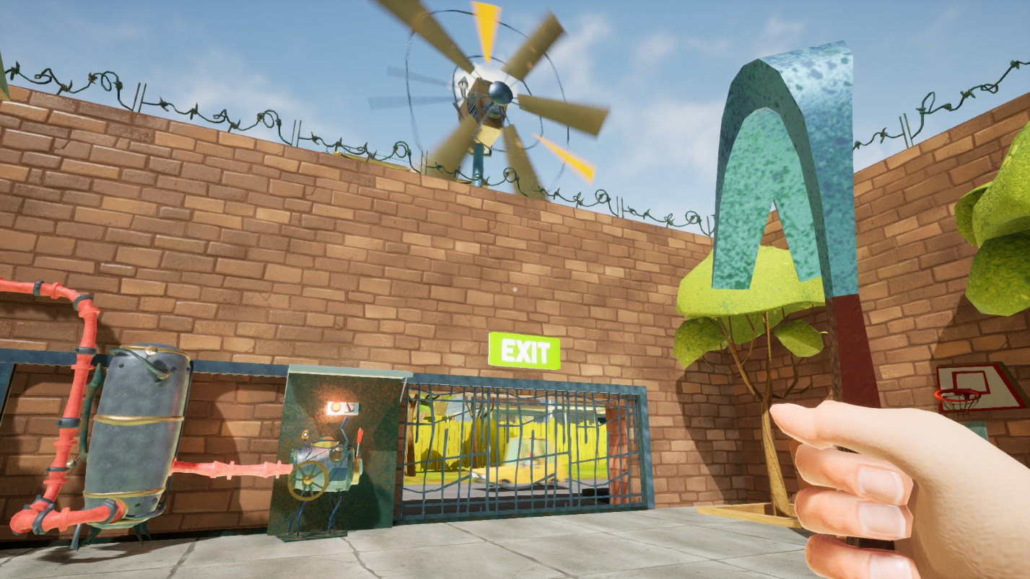

Figure 7: one of the possible views that the player sees after exiting the starting room – the exit gate

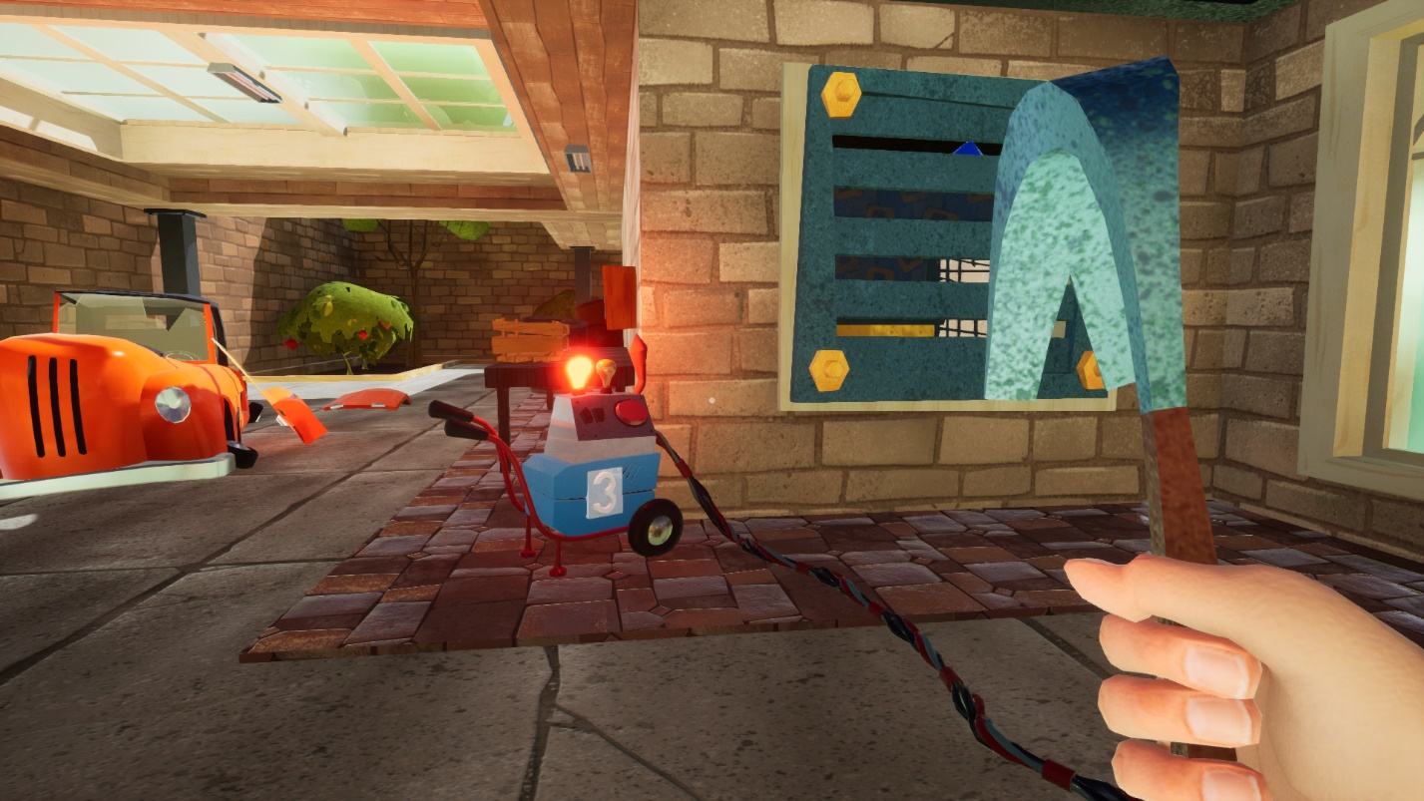

Figure 8: one of the possible views that the player sees after exiting the starting room – gasoline generator 3. Players can also see the vent that is secured with screws next to generator 3, and if players get closer and look through the vent, they will see generator 2

There are some features that were implemented to draw the player into the exit gate, which are: one, there are cars passing by the house entrance and whose engine can be heard from a distance, and as we know, movement can oftentimes draw the player’s attention, especially when everything else is stationary. Two, there is a giant spinning windmill with steam coming out that can be seen from many areas of the level, which also serves as a landmark for players to orient around the level, and as players take a closer look, they’ll notice the exit sign attached near the gate, which explicitly tells the player that this is their final goal and this is where they’ll need to go through to exit the house. And three, there is a long red pipeline that contrast from the wall that is attached to the exit gate motor; this pipeline is immediately visible as players leave the room through this window. As players get closer to the gate and the motor component that is attached to it, they’ll notice that there is a lever attached to the gate motor, and there is a red lightbulb that is placed above the gate motor. At this point, players might attempt to actuate the gate motor by pulling the lever down to attempt to open the gate or at least see what it does (it is assumed that the player has at least seen the concept of a lever in a machine that can be pulled down to make the machine attached to it do something), and because it does nothing, players could make the connection that when a component in the game had a red light, it’s a no-go, and when it’s green, it’s a go (similar to the traffic light convention commonly used in many parts of the world).

If the player decided to inspect the gasoline generator on the other side first, they will notice that the gasoline generator has a number attached to it (number “3”), but might not know at the moment what is this number for, and if they push the generator’s button, they’ll see that the generator’s lightbulb turned green, which hints the player that the other lightbulb placed by the motor by the exit gate could also turn green at some point and something could happen. Players will also see steam coming out of the generator, which tells them that this generator is doing/did something, and if players look around, they’ll see that there is a cable connected to this generator that goes somewhere on the other side of the house, so because the player might be intrigued to see what the generator did, they might follow the cable what is the generator connected to and see what the generator did to the thing connected to.

Regardless of which window the player uses to leave the room, they’ll notice that both the generator and the exit gate have something that connects them to the other side of the house, i.e. a cable line and a pipeline respectively, both of which lead to the other side of the house, so it is likely that players will go to the other side of the house to investigate and search for clues. As players walk around the house to see where the cable and the pipeline previously mentioned lead to, they might run into the bushes and learn that they don’t have collision, which tells players that they don’t have to worry about colliding with the bushes. As a matter of fact, these bushes are designed so that they effectively block the father’s sight so that players can move through the garden without being noticed. This is one of the path options that contributes to goal #2.

As the player reaches the other side of the house, they’ll notice the pool area, particularly the pool shed, which has three wires leading to a large switch attached to the shed with lightbulbs, one of the wires being the wire that comes from generator 3. This shed also has steam coming out of an exhaust from the roof, has the lightbulbs from the inside turned on, and is placed near the pipeline that traces back to the exit gate motor previously shown. All these features were designed to draw the player into this part of the map as it is the next major objective of the level.

If the player decided to go follow the red pipeline, they will see that it is attached to this big cylindrical prop, which is meant to be a water tank. As the player approaches this area, they’ll notice the damage on the roof/scaffolding nearby, and because of the placement of the wood pieces and the working light pointing toward this area, players will see that there is a valve component attached to this pipeline that has a missing handle as shown on **figure 9**. Players will hopefully be able to tell that it’s a valve with a missing handle since it looks like the valve attached to the pipe on the starting room; this is another reason why valves were introduced as early as possible in the level. And if players proceed to investigate the pool shed, they’ll see that there is a wheel handle attached to a component inside the pool (which the game calls it a pressure meter). If the player has played Hello Neighbor before, they know that this handle can be used to actuate the valve with missing hand previously mentioned, thus giving the player a reason to go into the pool shed.

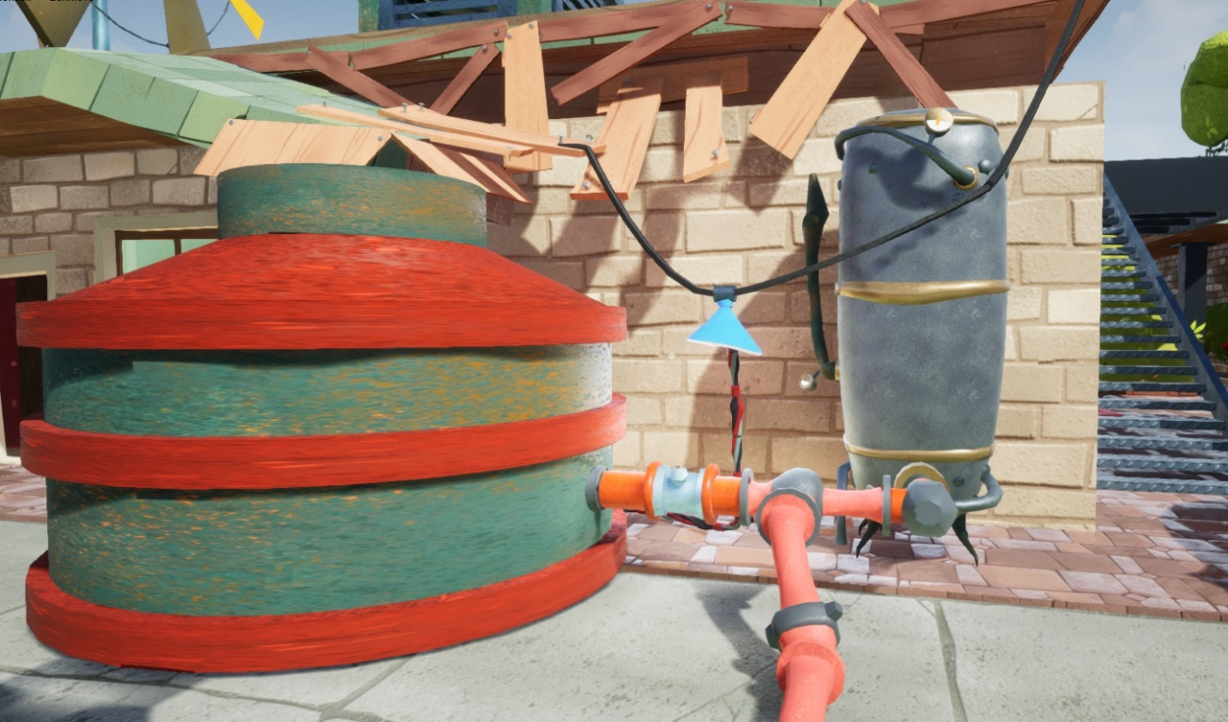

Figure 9: Area of the level containing the water tank that is connected to the exit gate.

## Find and Activate Gasoline Generators 1 and 3

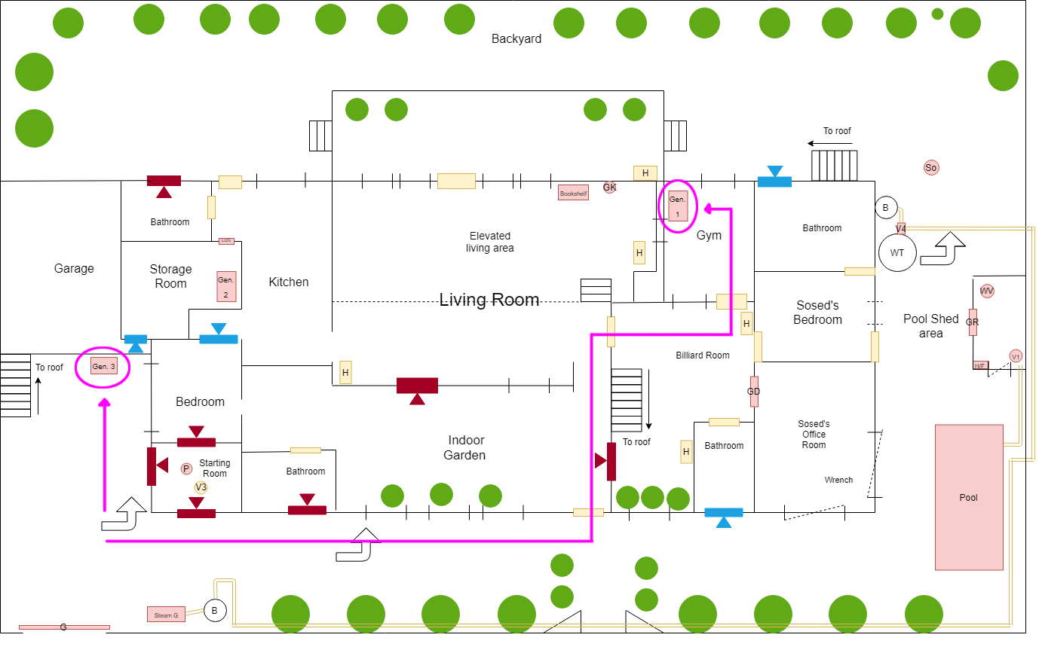

Figure 10: A possible route to reach gasoline generators 1 and 3 from the starting room

### Summary

Once the player goes to the pool area, they will notice three wires leading to the grate door of the pool shed with a switcher and light indicators labeled with numbers, which corresponds to their respective gasoline generator.

* 1. All these cables hint the player that the pool shed is their next immediate goal.
  2. These light indicators serve as a progress indicator.

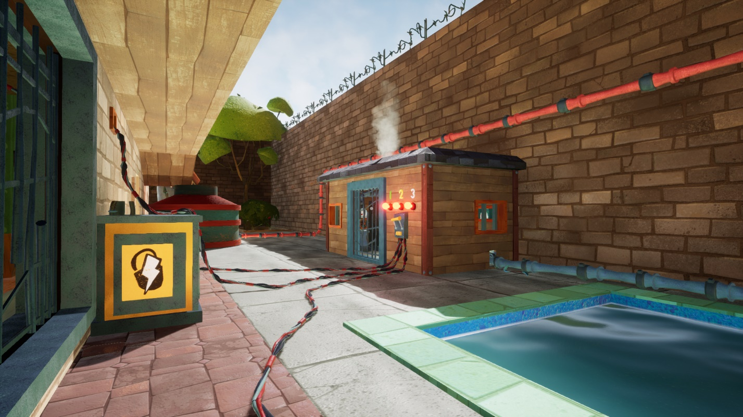

Figure 11: in-game view of the pool shed after following the cable from gasoline generator 3

After following the cables, players will notice that two of the generators (generator 1 and 3) can be accessed and activated (switched to ON indicated with the green bulb and the steam coming from the gasoline generator being switched ON), and they can be done in any order. After switching these generators to ON and returning to the pool shed, they will notice that two of the three lightbulbs (lightbulb 1 and 3) from the switch indicator have turned green as shown on **figure 14**, thus hinting the player that there is one more to go.

### Puzzle Flow

As the player stumbles upon the pool shed, they’ll attempt to actuate the door switch to see what it does, and because not all the lightbulbs are green, the pool door won’t open (same idea with the exit gate). At this point, players will notice that the lightbulbs attached to the door switch has numbers placed next to them, and if the player pushed the button on generator 3, they’ll notice that the lightbulb with the label “3” has also turned green. At this point, players might understand that the number attached to the generator is linked to the number attached to the corresponding lightbulb on the pool shed, so the other two red lightbulbs hint the player that there are other two things, presumably gasoline generators labeled “1” and “2,” that are also connected to the door switch, and because green oftentimes mean good and progress as in many other games, players might want to turn all the lightbulbs green to see what happens and hopefully make progress in the level. (see the **additional level highlights section** to see why the generators were numbered the way they were numbered)

As the player looks at the other two cables connected to the door switch from the pool shed, they’ll notice that they both go inside the house, so at this point, players will likely enter the house if they haven’t already and find out that’s connected to lightbulbs 1 and 2. As they enter through this bedroom, they might notice the wardrobes in it and might be interested to search them to see what they have inside. To reward the player’s motivation and curiosity, a cork gun was added in one of the wardrobes, which can be used to hinder the father from catching you by shooting corks at him to stunt him temporarily. This also tells the player that the level might reward you later with something else you keep looking around, which is the case with the green key (will be discussed later in this document). There are also all these objects that the player can grab to throw them at windows to break them (and distract the father) or power-throw them to the father to stunt him for a longer period.

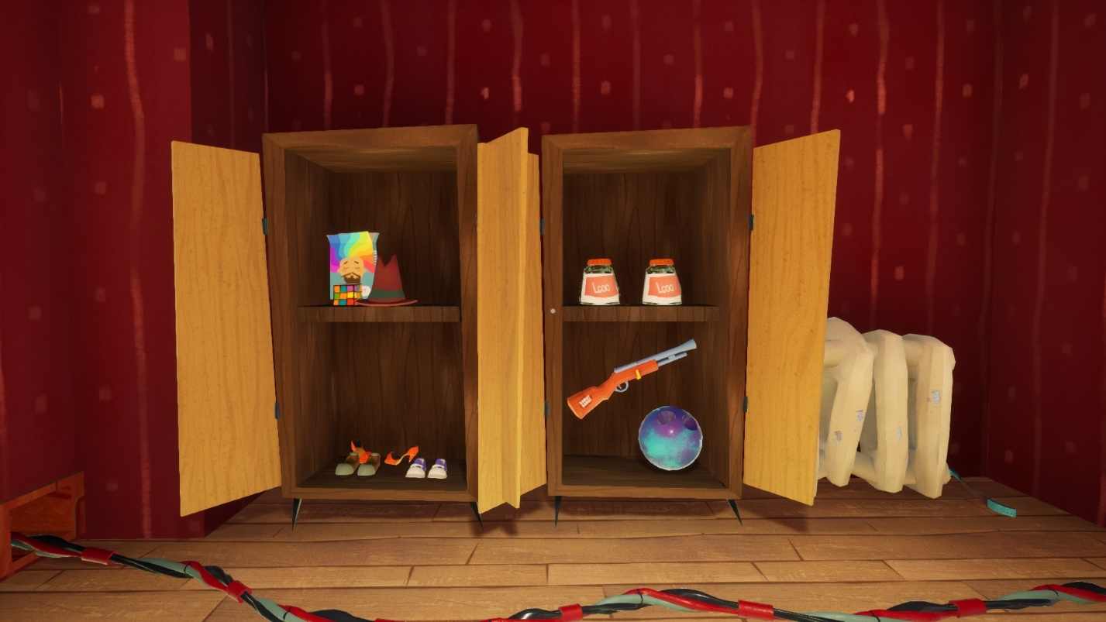

Figure 12: the wardrobes inside the father’s room opened showing its inventory. This image also shows the cable that connects generator 1 and the pool shed multi-bulb door switch.

As the player continues to follow the cables, they’ll see that one of them leads to the weight room. This generator was placed in this room because players were naturally attracted to this room in previous playtests, presumably because of its uniqueness and the fact that has an inside window, which is a feature that distinguishes this room from the other rooms. This also makes it so that if players haven’t found any of the generators yet might find this one first because they might have been drawn to this room by its unique features. As players turn this generator green, they might go back to the pool shed to see if the generator does that the player think it does, which is to turn the corresponding lightbulb on the pool shed green as well. And if players look back at the pool shed, the lightbulb labeled 1 has turned green as expected.

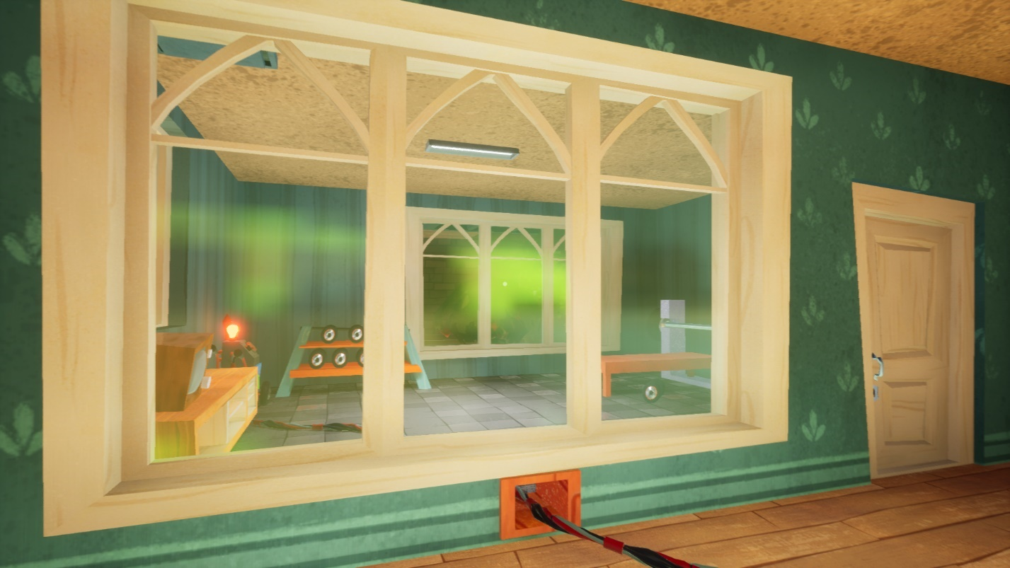

Figure 13: the weight room seemed from inside the house.

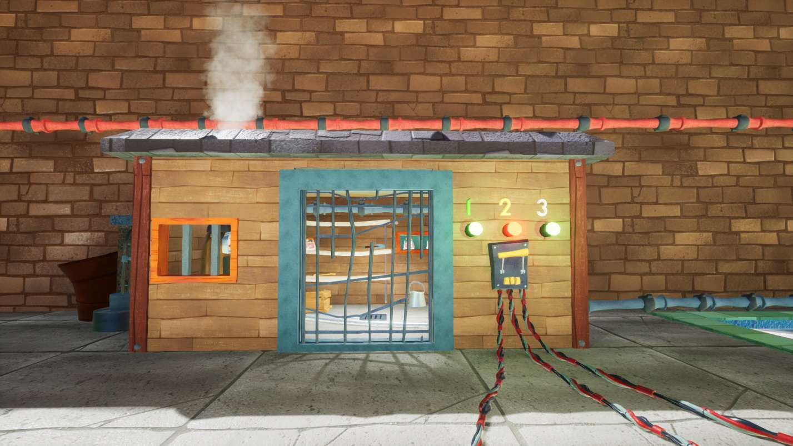

Figure 14: the pool shed after generators 1 and 3 have been switched ON

What if the player decided to trace the source of lightbulb 2? Then if they follow this cable, they’ll see that this cable passes through this room on the ceiling with grated windows, and if players haven’t noticed already, there is a wrench placed in an area that contrasts with the rest of the room, and if the player has played Hello Neighbor before, they’ll know that the wrench is oftentimes an useful tool that they can use to their advantage to somehow progress in the game, so this gives the player a reason to go into this room.

As players move along to figure out the location of generator 2, they will be presented with several flow paths and options that players can take to move around the level and outsmart the father, such as sneaking around clutter to avoid being seen by the father (as shown on **figure 15**), going through vents and boards that can be removed to open up paths (as shown on **figure 16**), and hiding on closets to avoid being seen when the father is nearby. Additionally, players can take the indoor stairs inside the billiard room, which takes them to the roof of the house. There are also two other stairs on the outside of the house that players can use to get in the roof as shown on **figure 1**.

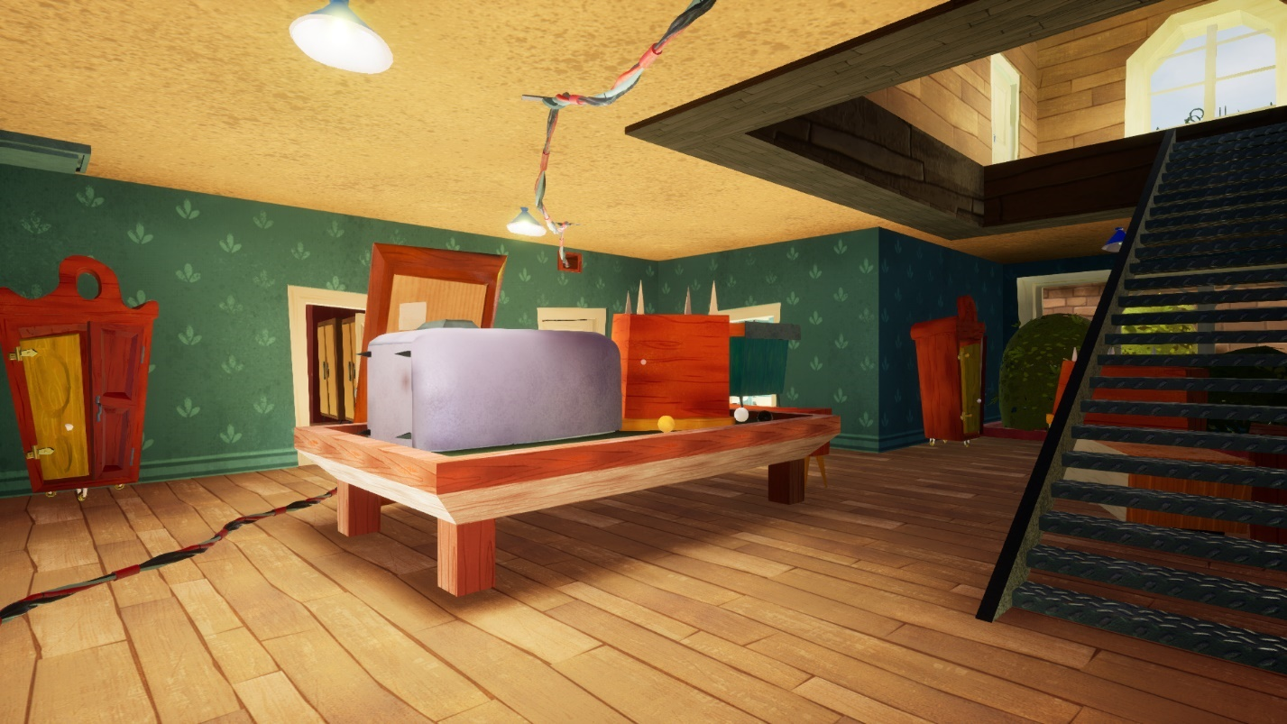

Figure 15: the billiard room, this room has clutter for players to break lines of sight and sneak around the father. Additionally, this room contains a staircase that leads to the roof of the house, which serves as an alternative path to traverse the house. This

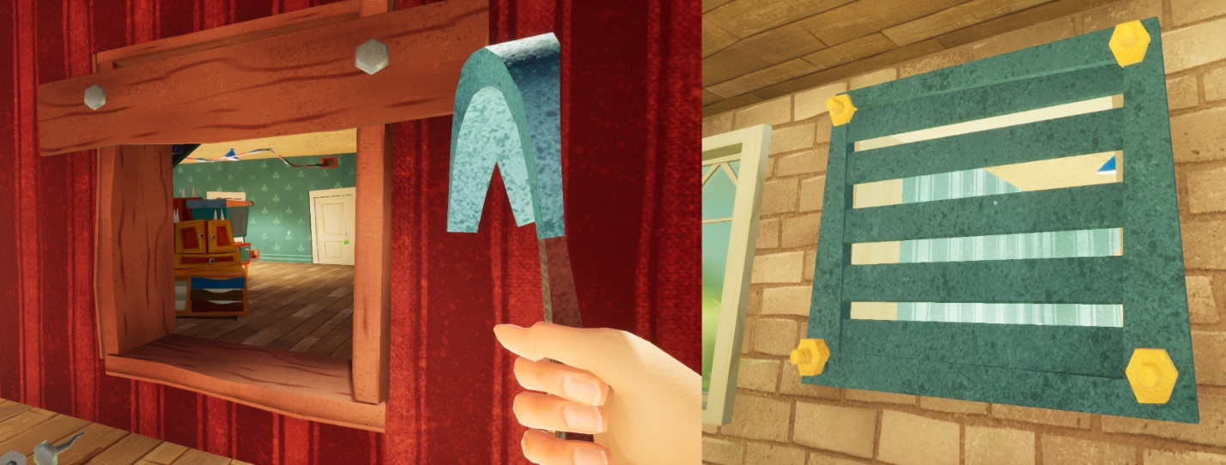

Figure 16: Some alternative route choices that the player can unlock and take to move around the house. Vents require a wrench to be removed, which gives another reason to break into the father’s office to get the wrench.

The cable leading to generator 2 was purposely placed in the ceiling mainly for three reasons:

1. **To make it stand out in the level:** because the ceiling has a plain and a relatively bright color, the cable contrasts from the ceiling due to their differences in color and brightness.
2. **To further distinguish it from the cable leading to generator 1:** because this cable is somewhat near the other cable that connects generator 1, there are higher chances that players would confuse them if both cables were to be laid on the floor.
3. **Having one cable on the floor and one on the ceiling increases the chances for the player to notice the cabling going on:** if players aren’t looking at the floor, they might not notice the cables going on the floor but might notice the cable on the ceiling. Conversely, if players aren’t looking at the ceiling, they might spot the cables on the floor.

The cable leading to generator 2 runs across the house, which serves as an axis from which the player can reference to orient themselves inside the house. Additionally, this cable serves as a way to guide the player to the pool shed from the inside of the house if they haven’t found it yet, and if players decide to go the other way to see what’s on the other side of the cable, they will find a generator, in this case being generator 2, and as in the case of generator 3 players might also want to follow the cable to see what’s connected to generator 2, which again leads to the pool shed. As players get close to generator 2 (located in the storage room), there is also this broken wire with audible and visible sparks coming out of it, which was purposefully placed there to draw the player’s attention to this room. Additionally, this room was given a grate door instead of a standard wooden door so that players can see what’s inside the storage room (see **figure 17)**; having a grate door instead of a conventional wooden door also draws the player’s attention as grate doors are less usual that wooden doors in real life. As players examine this room, they’ll notice that there is also a vent on the other side of the room that they might be able to open, so at this point, player might also want to go outside to reach this vent or at least see if there is an alternative way to get into this room.

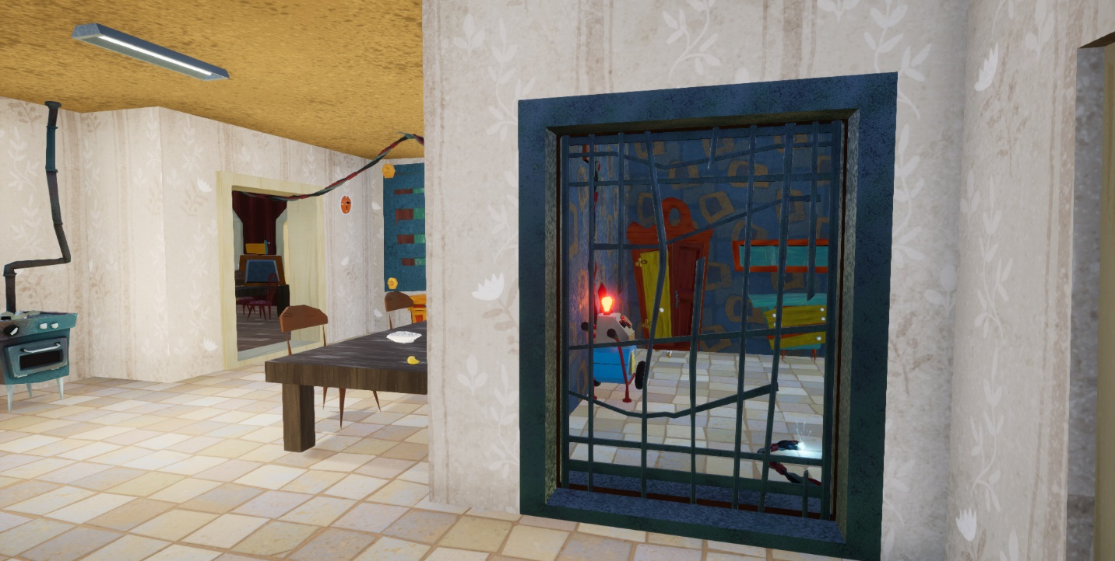

Figure 17: the storage room as seen from the kitchen

Once the player goes outside to see the vent from the other side, they’ll see the vent from **figure 8** and that it is bolted down with yellow bolts. Players might attempt to remove them with the crowbar to no avail, so at this point, the player might go back to the pool shed to see what else they can do to progress through the level.

## Gain Access into the Office Room to Pick the Wrench

### Summary

The office room contains the wrench needed to open vents, such as the one that leads to the storage room containing generator 2.

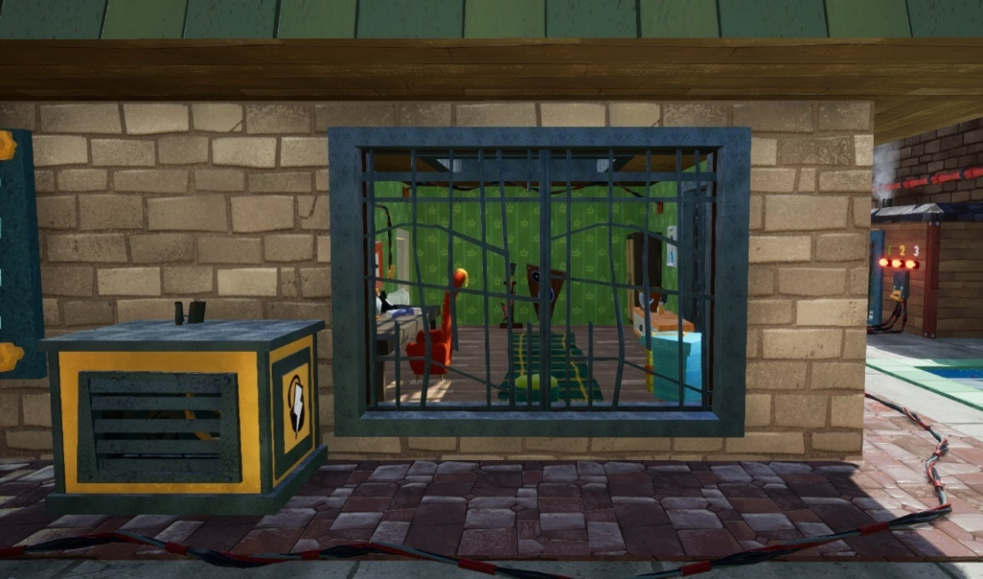

Figure 18: the office room viewed from outside.

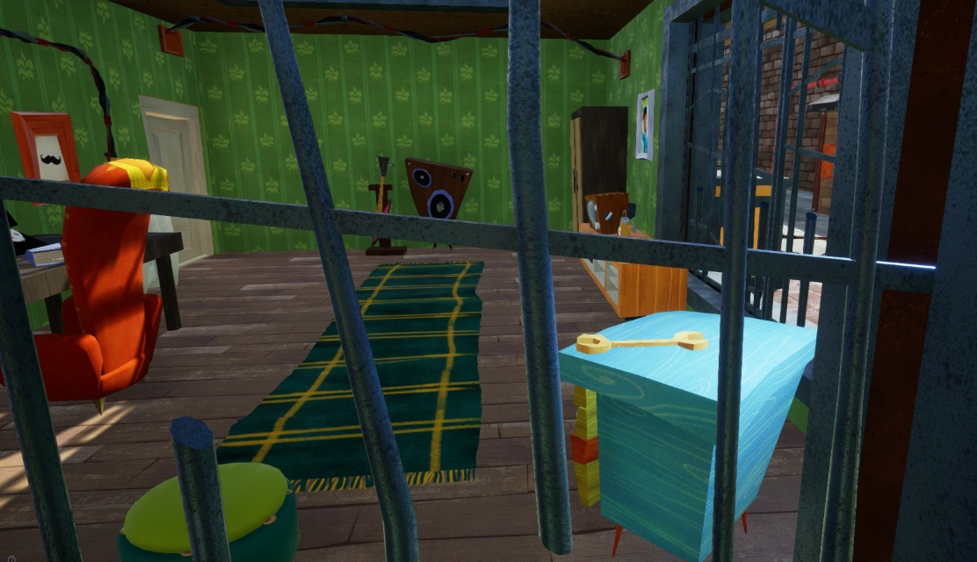

Figure 19: what the player sees when taking a closer look into the office room

To gain access into the office room, the player can take either one (or both) of the following routes:

#### Entering Through the Roof Opening

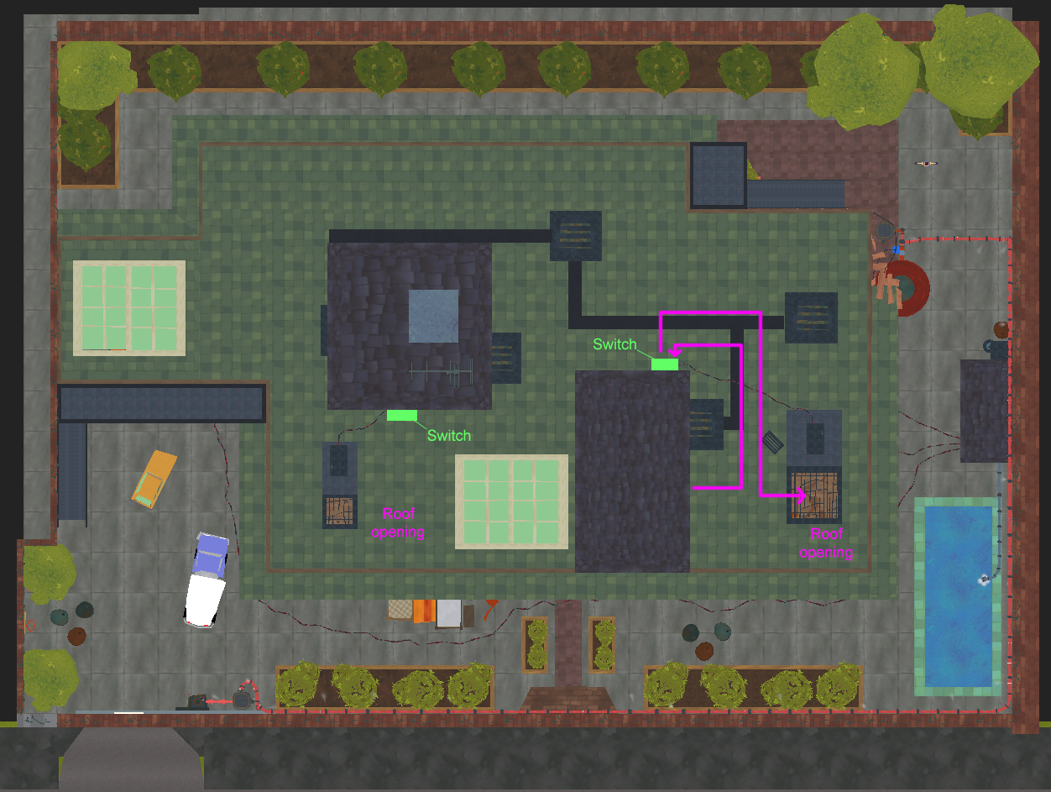

Figure 20: top view of the level in the UE4 editor (unlit) showing the roof of the house and the player’s path for entering the office room through the roof

To enter the office room through the roof, the player must:

1. Go to the house roof (any stair will do).
   1. There are 3 emergency stairs that the player can use to reach the roof of the house
      1. two located outside on opposite ends of the level: one near the starting room next to the garage, and the other near the water tank linked with the red pipeline
      2. One located inside the house on the billiard room.
   2. There are also two additional (implicit) ways that the player can use to reach the roof:
      * 1. Climb on top of the clutter set next to the starting room (there’s a bed, tables, and other furniture placed together.
        2. Go to the water tank (green cylindrical container with a red cap) connected with the red pipeline and climb on top of it (reach water tank, step onto the pipe coming out to the boiler and jump to the water tank and to the red cap and finally to the roof).
2. Go towards the office room
3. At this point, the player will see a grate motor sitting next to the roof opening (closed by default), and there is a cable leading from the motor to its switch nearby (if players haven’t noticed it already).

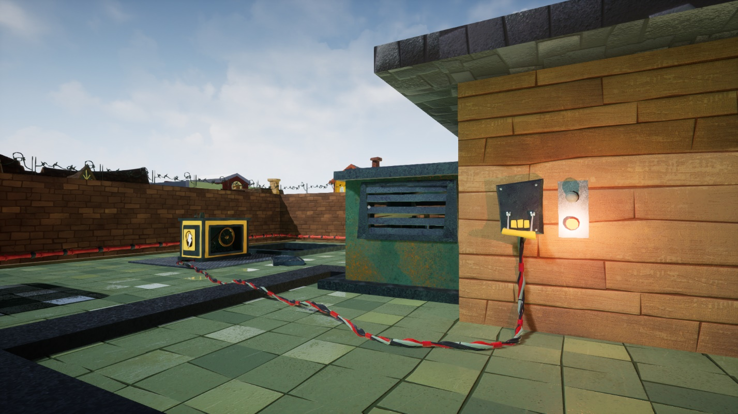

Figure 21: roof view of the ceiling grate motor (yellow-looking box) that opens the ceiling grate that leads to the office. From this view, the player can see the physical connection between the ceiling grate motor and its corresponding switch

1. Go to the switch linked to said motor and activate it, the motor will start (the player will hear the grate sliding, the motor actuating, and will see steam coming from the motor as well as see its wheels rotating).
2. Go to the roof opening and jump down into the office room.

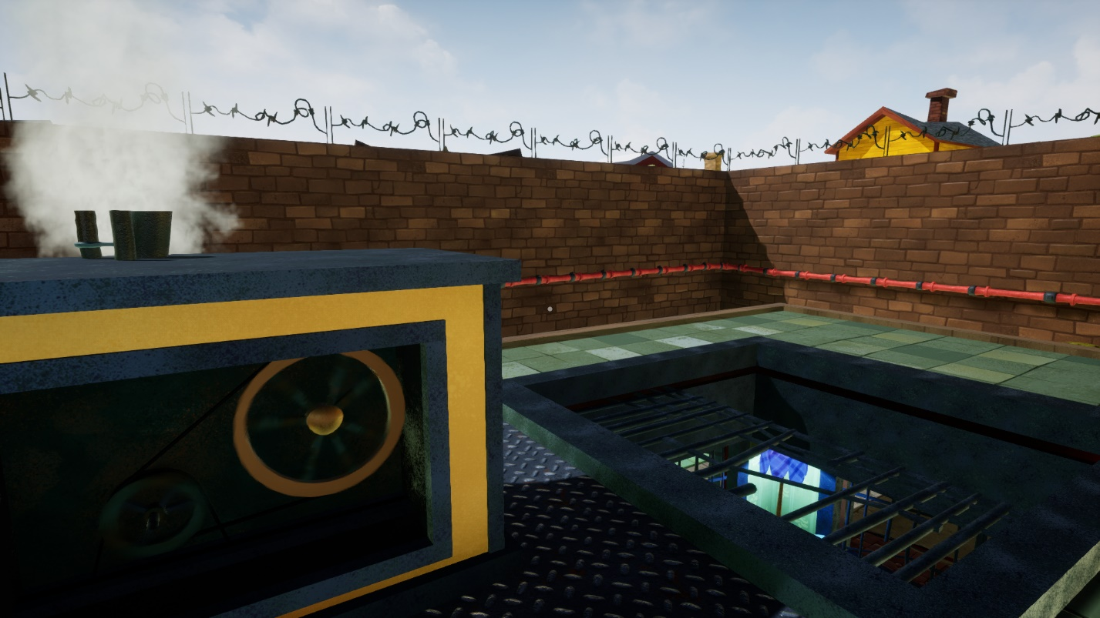

Figure 22: the ceiling grate motor opening the grate to enter the office room

#### Entering Using the Green Key

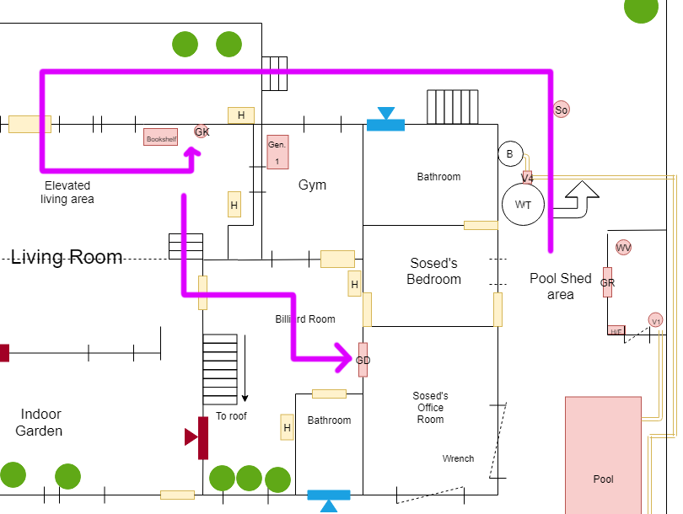

Figure 23: top down portion of figure 1 showing one of the possible player's path to one of the solutions for entering the office room (using the green key)

The door to the office room is locked with a green lock, so this hints the player that they need to find a green key first to unlock this lock and the door. To find the key, players need to:

1. Go to the living room where the jazz stereo is located
   1. The jazz stereo, the lamp nearby, the cable going around the wall picture nearby, the bear rug pointing towards the bookshelf next to it with some of the books fallen, and one of the books being red (where all the other books are light purple) are all the cues that are used to drag the player’s attention to the area.
2. Remove the red book from the bookshelf and activate the switch beneath where the red book was. The picture wall next to it (mouth closeup) will tilt and reveal the green key. Take this key

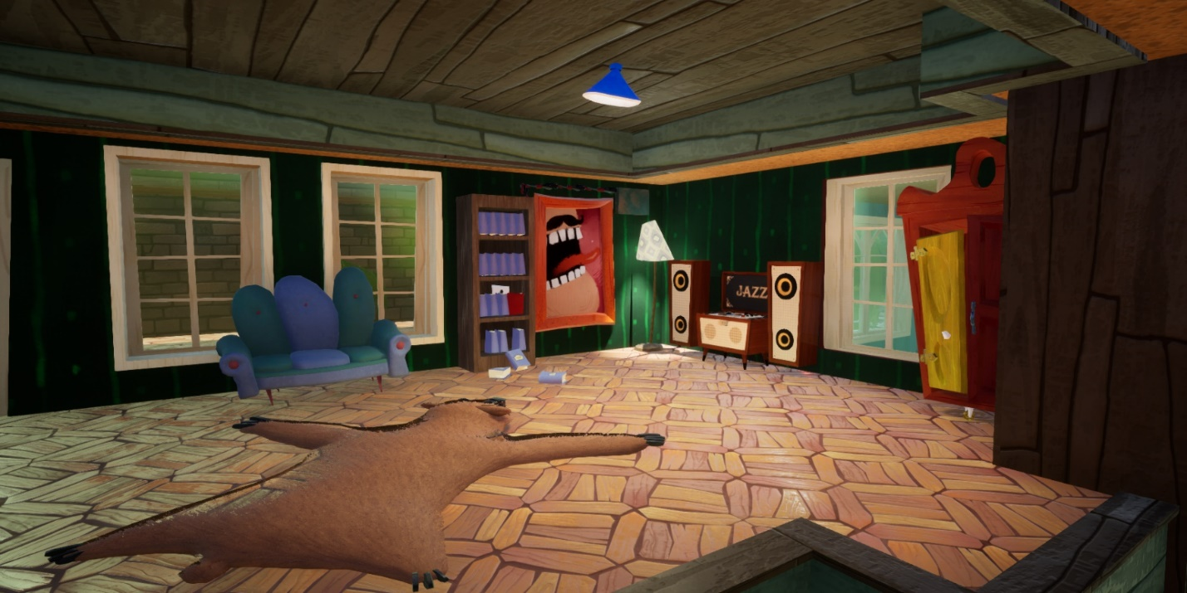

Figure 24: view of the bookshelf containing the green key in the living room

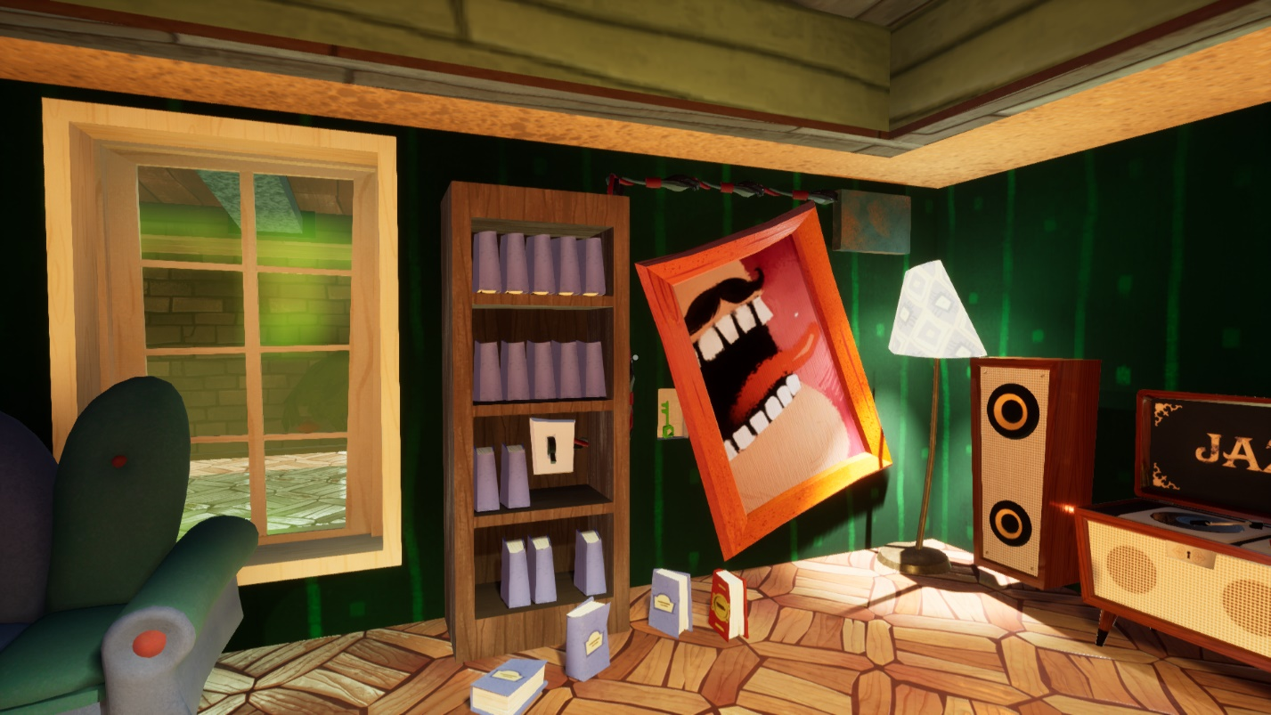

Figure 25: when the player discovers the hidden switch on the bookshelf and the green key hidden behind the picture frame

1. Go to the door to the office room and use the green key to unlock the green lock to unlock the door that is attached to.

This alternative route was designed to reward observant players as well as to give them one of those “aha! Moments” that support design goal #3.

### Puzzle Flow

As the player go back to the pool shed, they might notice the wrench again (if they haven’t already). Because the wrench also has the same flashy yellow color that the bolts securing the vents around the house have, and we know from real life that wrenches can unscrew bolts (hopefully the player knows this as well), then our goal is now shifted to how to get inside the office room.

If players explore around the office room, they’ll see that there are potentially two ways go get in there; if they go inside to find the door leading to it, they’ll see that the door is locked with a green padlock, and if players go to the roof and go to where the office is, they’ll notice that there is a roof opening similar to the one from the starting room that is also locked with a grate hatch.

If the player attempts to enter the office through the roof, they’ll notice a yellow box-looking object that has some wheels (as shown on **figure 21** and **22)**, which hints that this is a motor of some type, and that it is placed nearby the roof opening of the room. If the player hasn’t noticed already, there is a cable attached to this motor that leads to a switch with a light indicator similar to those from the generators and the exit gate (see **figure 21**), and if the player switches it on, its light turns green and they’ll hear the ceiling grate sliding open, the motor making some noise, turning its wheels, and fuming some steam to drag the player’s attention so that they can see what the switch does, which in our case, to open the ceiling grate (see **figure 22**). This reinforces the idea that when the lightbulb of a given object in this level is red and turns green, you have made a progress in the level and that things open or are unlocked when the light indicator is green. This also hints the player that once the lightbulb from the exit gate turns green, they might be able to actuate the gate motor to open the gate and escape since this motor also has wheel and other moving parts. As the player approaches the roof opening that leads to the room with the wrench, they’ll immediately see the wrench there, after which the player drops down to collect it.

If the player decides to look for the green key, they might go inside the house to look for it since we know from real life that keys tend to be stored somewhere inside houses rather than outside. As players go inside this room, they might notice the jazz stereo setup inside the living room as shown on **figure 24** because of its decoration and lighting that stands out to the player: there is a jazz stereo, there is a strange-looking painting of the father’s mouth, a bookshelf with a few books that fell to the ground, a red book on the bookshelf that is unique from the other books from the book shelve, and a bear rug pointing at the bookshelf. As the player takes a closer look to this area, they see a strange wire going around the painting that goes to the bookshelf, particularly to this white switch that contrasts from the dark brown color of the bookshelf, and if the books are removed from the bookshelf, a hidden switch is revealed to the player. And if the player actuates this switch, they’ll see the picture frame tilting, revealing the green key and giving the player one of those rewarding moments from design goal #3.

## Find and Activate Generator 2

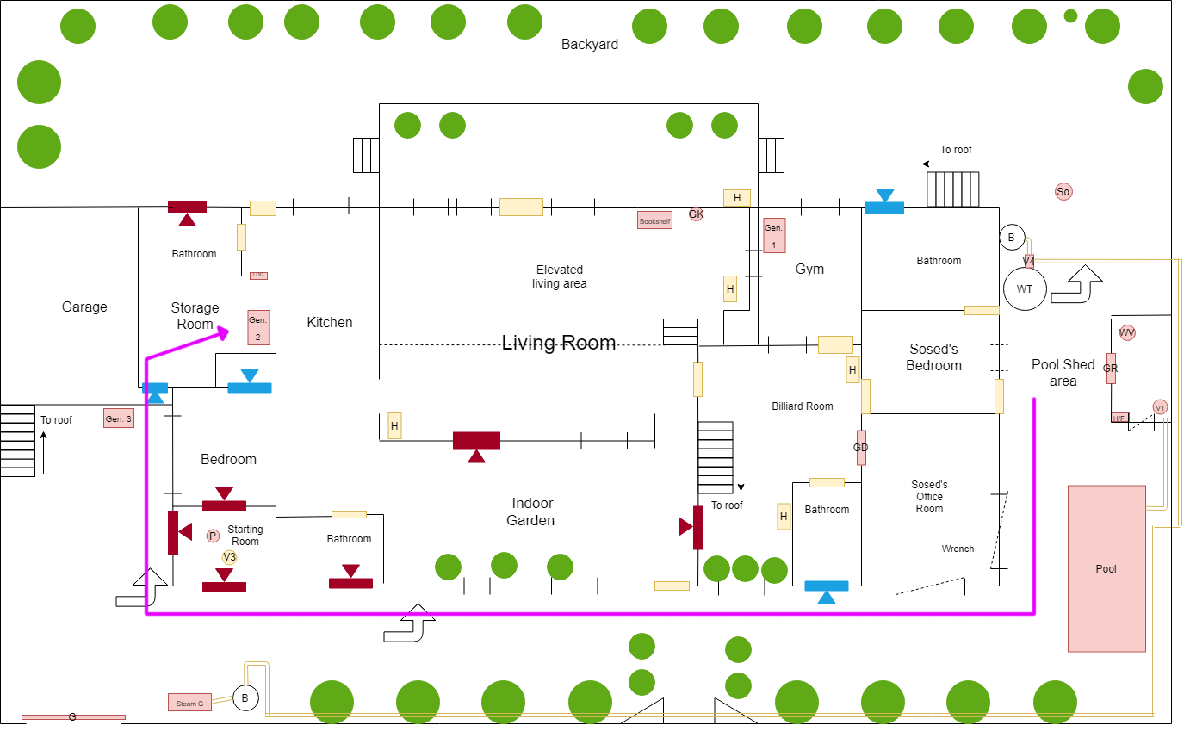

Figure 26: one of the possible routes (indicated by magenta line) that leads to generator 2

### Summary

Once players get the wrench, they must go back to the vent leading to the storage room to unscrew it with the wrench to enter the storage room and switch gasoline generator 2 ON.

## Enter the Pool Shed to Pop the Handle out of the Pressure Meter

### Summary

1. Go to the pool shed. All the lightbulb indicators should be green
2. Actuate the switch next to the grate door to open the pool shed.
3. Once inside the pool shed, the player must turn the water pump valve (the valve attached to the pipe leading towards the pool. Players will be able to hear water running through the pipe and see water coming out of the pipe leading to the pool.

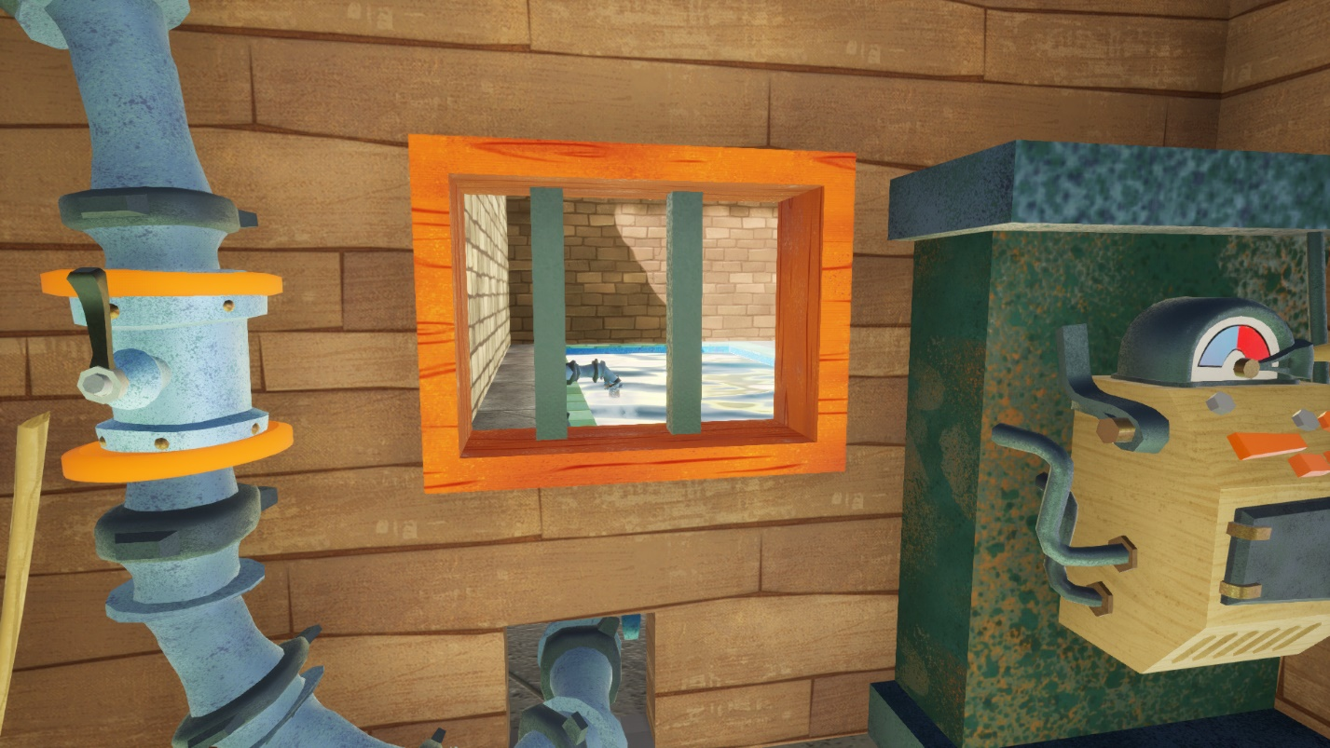

Figure 27: view of the pool with water coming out of the feeding pipe (blue pipe on the left). The heater/freezer is located on the right side of the shed window facing the pool.

1. Set the heater to freeze (left switch looking prop on **figure 27**) to burst the valve from the pressure meter as shown on **figure 28**.

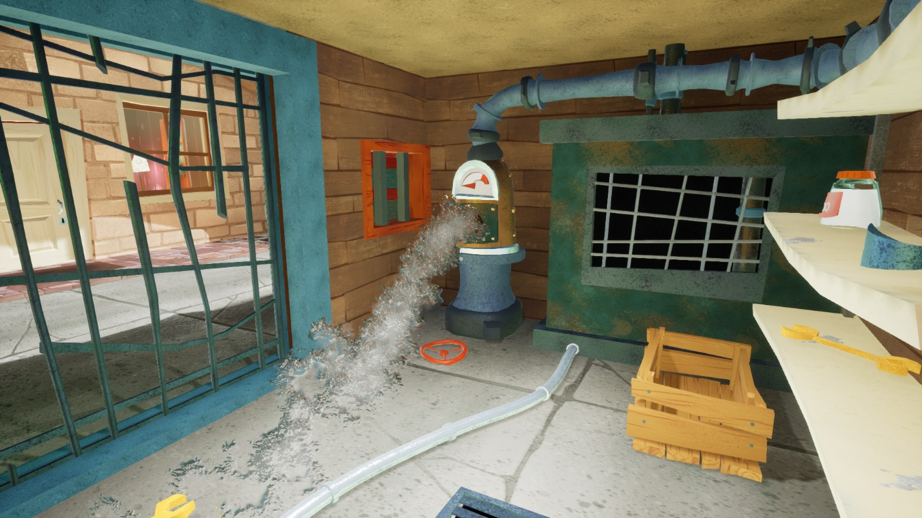

Figure 28: view of the pressure meter with valve burst

#### Logic Behind Puzzle

Because it was attempted to pass water into the frozen pool, pressure built up on the pressure meter and burst the wheel handle out of the pressure meter, which is somewhat analogous to the pipe with the cork stuck from the starting room.

1. Pick the wheel handle from the ground (the wheel handle that popped from the previous step; it will be laying near the pressure meter as shown on **figure 28**).

### Puzzle Flow

Once the player returns to the pool shed, they’ll see that all three lightbulbs have turned green, and if they actuate the switch to see what it does, it opens the pool shed as expected. As the player proceeds to enter the pool shed, they’ll see another pipe with a valve that is connected to another component (referred as pressure meter in this document). If players open the pipe valve, they’ll hear water running through the pipe, and if they look at the other end of the pipe, they’ll see that the pipe is feeding water to the pool. If the player closes the pipe valve, they’ll see that the pipe leading to the pool stops feeding water to the pool, thus making the player conclude that this valve controls the pool water influx.

Players might also attempt to actuate the pressure meter to see what it does. However, it does nothing.

Players will also notice the heater/freezer (which is currently set to heat); it has a lever and seems interactive, so they will likely attempt to interact with it to see what it does. If players pull the level, they’ll see that water from the pool is now frozen. Note that the placement of the pool shed actuators and the pool shed windows allow players to immediately see the reaction of these actuators.

At this point, the player might wonder: “What if we try to feed water into a frozen pool?” Or “What if I try to freeze the pool water while there is water running though this pipeline?” Players might feel like trying these just to see what happens. As the player tries to do either one of these things, they will hear a loud burst sound and water leaking from somewhere nearby, and as they turn around, they immediately see the pressure meter busted and squirting water out with the wheel handle on the floor which can be mildly rewarding and amusing to the player. The idea behind what happened in this scenario is that because the player clogged the pool pipeline by freezing the pool’s water and attempted to push water through the clogged pipelines of the pool system, the pressure meter developed enough internal pressure to pop the wheel handle out of it. This is that the initial vignette from the starting room was also trying to foreshadow the player, and once players make the connection between what happened with the pipe on the starting room and what happened here, they’ll also feel ingenious about it (again, supporting design goal #3).

## Feed Water to the Steam-Powered Garage Gate Motor

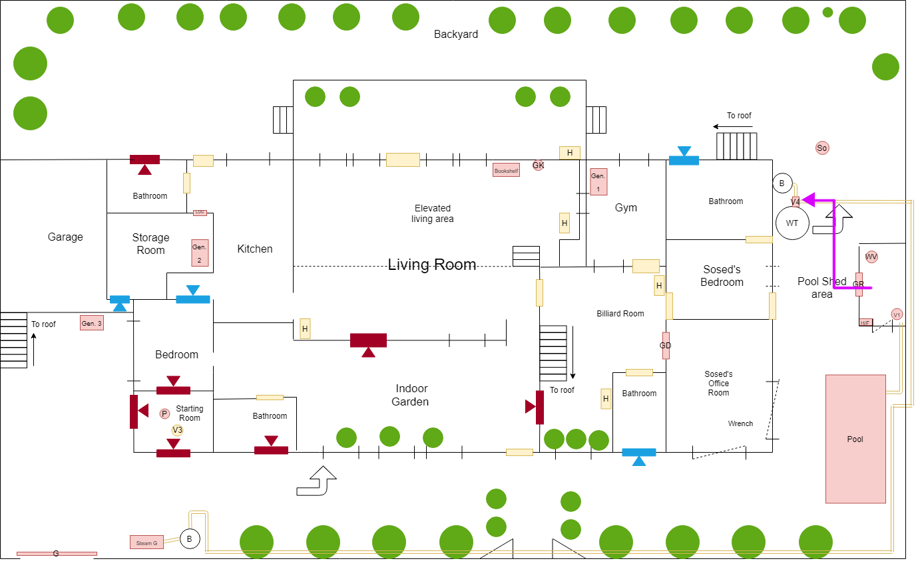

Figure 29: top down diagram of the level (first floor only) showing the player path from the pool shed to the water tank valve

### Summary

The player must go to the water tank connected to the red pipeline and use the wheel handle to open the pipe valve attached to it to pass water into the boiler, which feeds the boiling water to the exit gate motor, after which its light indicator finally turns green. This gate motor, which is called steam generator in the base game, is steam-powered.

As an additional layer of conveyance, there is also steam coming out of the red pipeline once the valve connecting the water tank is opened to indicate that the boiling water is going through the red pipeline, see the “Red Pipeline Steam Particle” from the Custom Functionality section of this document to see more about this feature.

### Puzzle Flow

At this point, the player might remember that the red pipeline was connected to the water tank and that there was a valve with a missing handle next to the water tank (recall **figure 9**), and as part of the puzzle, players need to figure out that they can use the wheel handle to place it onto the valve with missing handle to actuate said valve. Additionally, the wheel handle looks flashy and seems like a useful thing to carry around, and if the player has played hello neighbor before, they know that this can be used to open valves that have a missing valve, such as the one on **figure 9**. Once the player actuates the valve from the red pipeline, they’ll see and hear steam coming out of the pipeline, which conveys the player that something is going on with said pipeline, and because this pipeline is connected to the motor from the exit gate, players will likely go back to the exit gate to see if anything changed on that end of the level.

## Open the Exit gate and Escape

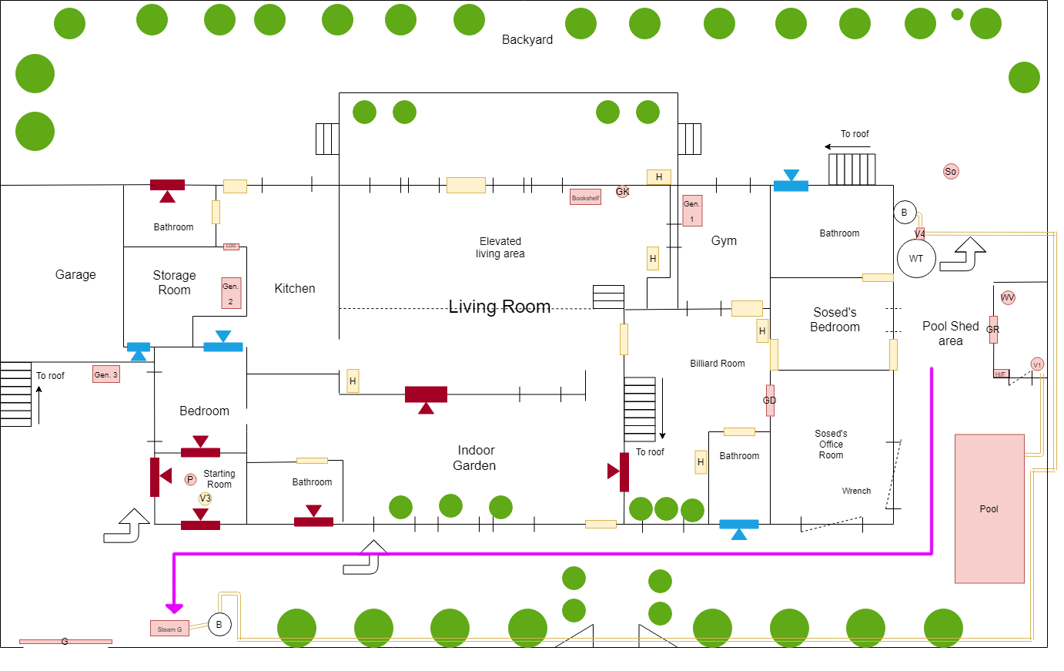

Figure 30: top down diagram view of level (first floor only) showing the path to the last step of steps to complete the level

Once the player returns to the exit gate, they’ll see that the light indicator next to the exit gate has turned green as shown on **figure 31**, which invites the player to actuate the lever attached to the gate motor. The player then pulls the lever to open and the gate finally opens. Once the gate is opened, the player can now escape the house. The level is now completed, and the mod takes you back to the main menu of the game.

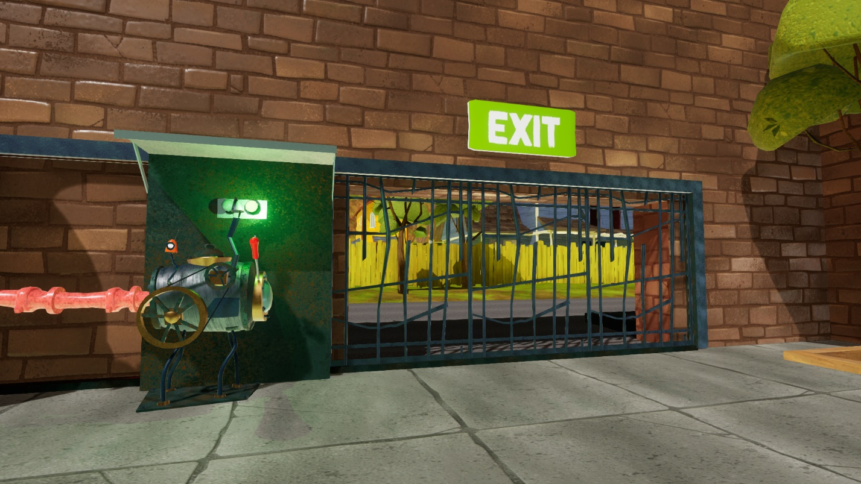

Figure 31: view of the gate with steam-powered garage gate motor with green light on, indicating the player that it is ready to open the gate and exit

# Additional Level Design Highlights

## The House Backyard

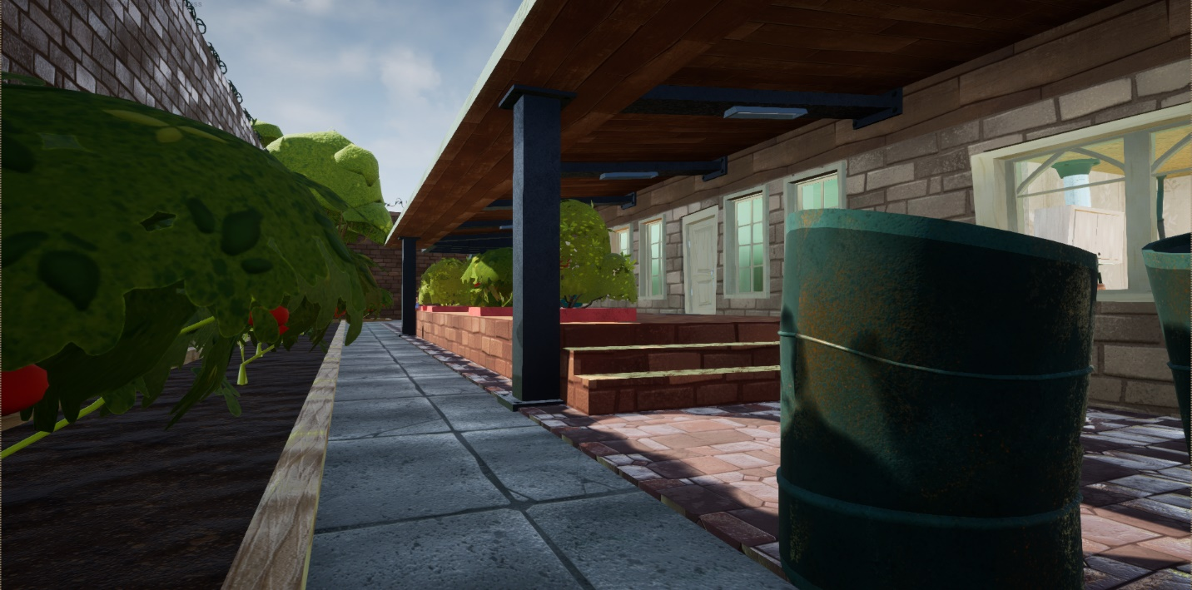

Figure 32: the house backyard

The house backyard has no gameplay critical features; however, it has some of the level features that can be used to outsmart Sosed. For example, it has bushes, which were modified so that they effectively block lines of sight. The collision of the bushes was intentionally removed so that it allows players to go through them and allow the player to use them as hide spots and safe passageways to move around the house while remaining invisible. Another feature that players can use to outsmart Sosed are the windows; players can break the windows and run away from this area to distract Sosed and make him go to investigate the broken windows. These features also support design goal #2

## Gasoline generator Numbering

The first generator encountered was labeled with a “3” instead of “1” because the model for number “1” provided by the game is a san-serif model, which might not be immediately recognized as a number 1 by the player. Another reason why this generator was labeled “3” was the fact that if it were to be labeled “2,” the cables leading to the pool shed will cross over at some point, which can be confusing for players to trace cables.

## Unlockable Paths

To give players more flow options, the level features boarded windows and vents that players can unlock with the crowbar and the wrench respectively to open more flow options. For example, a bathroom would normally be a dead end in a house, and if players happen to run into the bathroom while being chased by Sosed, they are likely to be trapped and caught. In this level however, players can open these windows, holes and vents to open escape routes

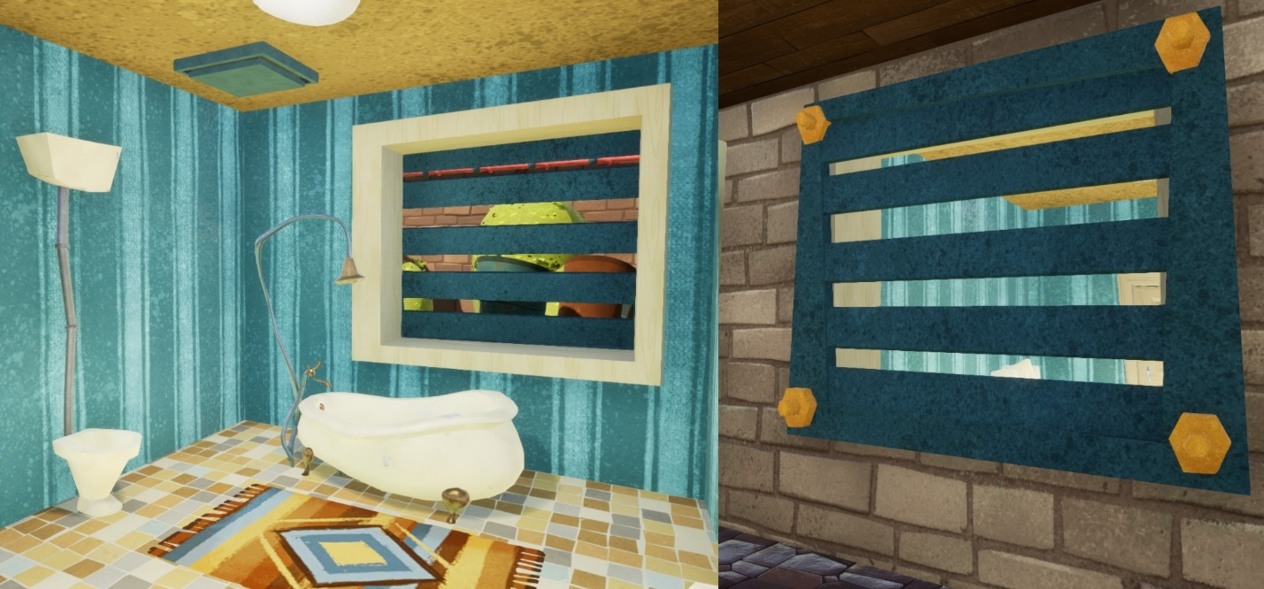

Figure 33: this is an example of a vent on a bathroom that can be opened with a wrench to open a new escape route

The unlockable vents and removable boards were all custom functionality added to the base game. The game did have boards that can be removed with a crowbar, but they only worked for locking doors. This didn’t fit the needs of this level.

## Other Features that Required Custom Blueprint Functionality:

* Starting Room Pipeline
* Pool Pump System
* Pool Shed Multi-Lock System
* Secret Picture Frame
* Light Indicators
* Red Pipeline Steam Particle
* Background Cars Passing By
* Custom Boards and Vents
* Ceiling Grate Motors

# References

[1] <https://steamcdn-a.akamaihd.net/steam/apps/521890/header.jpg?t=1533342069>